Blinkit Sales Analysis Report
Impact of Fat Percentage on Sales Performance

1. Executive Summary
Blinkit operates in a highly competitive quick-commerce environment where product assortment and customer preferences directly influence sales performance. This analysis was conducted to evaluate how fat percentage (Low Fat vs Regular) in food items impacts sales, and how this relationship varies across outlet size, outlet location, and item categories.
Using Blinkit’s historical sales data, an interactive dashboard was developed to uncover trends, patterns, and actionable insights. The analysis reveals that Regular fat products contribute a significantly higher share of total sales, but Low Fat products show strong performance in specific outlet types and locations, indicating opportunities for targeted assortment and marketing strategies.

Dashboard: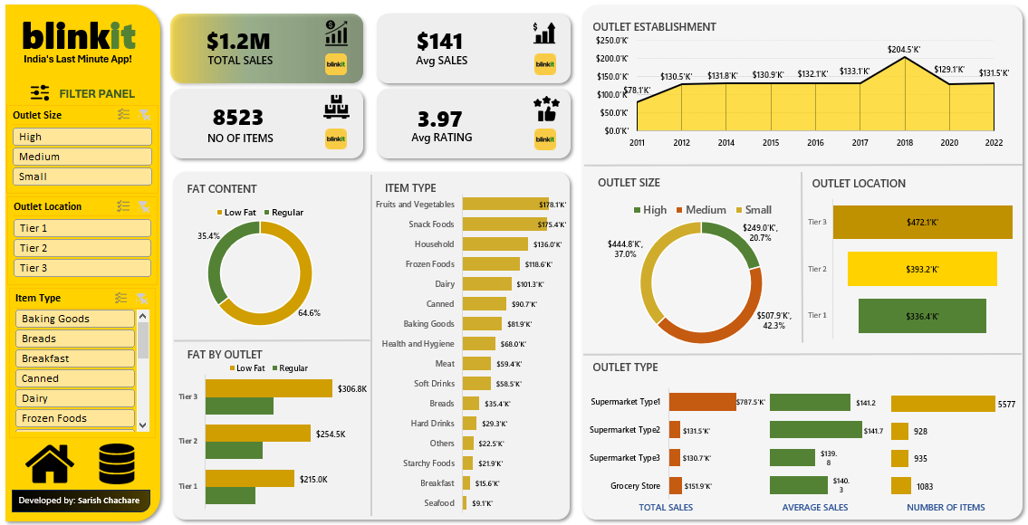
(figure 1: Overview of the Dashboard)

2. Business Problem Statement
Blinkit required a data-driven understanding of the following key business question:
“How does the fat percentage in food items affect sales performance, and how can Blinkit optimize its product mix based on customer preferences?”

Specifically, Blinkit wanted to:
- Assess whether Low Fat or Regular fat products generate higher sales
- Understand how this behavior differs across outlet size, location tiers, and outlet types
- Identify opportunities to improve sales through better product placement and assortment planning
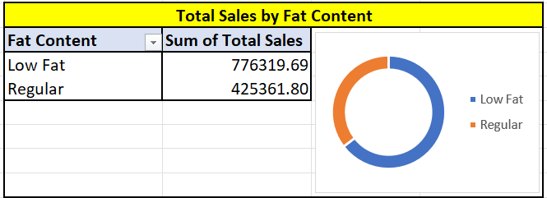
(figure 2: Analytical focus areas linking fat content with sales drivers)

3. Data Overview
The analysis was performed on Blinkit’s sales dataset containing:
- Product-level attributes (Item Type, Fat Content)
- Outlet-level attributes (Outlet Size, Location Tier, Outlet Type, Establishment Year)
- Sales performance metrics (Total Sales, Average Sales, Number of Items, Ratings)
Key KPIs derived include:
- Total Sales: $1.2M
- Average Sales: $141
- Number of Items: 8,523
- Average Rating: 3.97
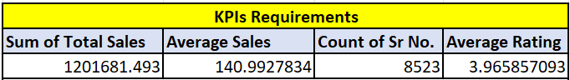
(figure 3: KPIs)

4. Analytical Approach & Methodology

4.1 Data Preparation
- Cleaned and standardized categorical variables (Fat Content, Outlet Size, Location)
- Aggregated sales metrics by Fat Content, Outlet Type, Outlet Size, and Location Tier
- Validated consistency across KPIs to ensure reliable comparisons

4.2 Analysis Framework
The analysis was structured around:
- Overall impact of fat percentage on sales
- Fat content performance across outlet locations
- Fat content performance by outlet size
- Category-level contribution of fat-based products
- Temporal trends in outlet establishment and sales

4.3 Visualization & Dashboarding
An interactive dashboard was created to:
- Compare Low Fat vs Regular sales contribution
- Enable filtering by Outlet Size, Location Tier, and Item Type
- Provide executives with a quick, visual decision-making tool

5. Key Findings & Insights

5.1 Overall Sales Contribution by Fat Percentage
- Regular fat items account for ~64.6% of total sales
- Low Fat items contribute ~35.4% of total sales
Insight:
Customers still show a strong preference for Regular fat products, making them the primary revenue driver for Blinkit.
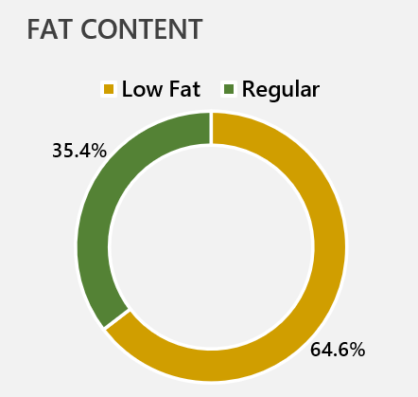
(figure 4: overall contribution according to the fat content present in items)

5.2 Fat Content Performance by Outlet Location
- Tier 3 locations generate the highest sales for both Low Fat and Regular products
- Regular fat items dominate sales across all tiers, but Low Fat products show relatively better performance in Tier 1 locations
Insight:
Urban and semi-urban customers are more receptive to Low Fat options, likely due to higher health awareness.
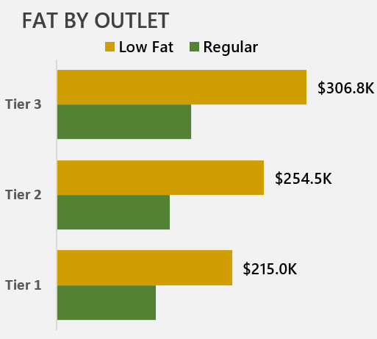
(figure 5: overall performance based on fat content by outlet location)

5.3 Fat Content Performance by Outlet Size
- Medium-sized outlets contribute the highest overall sales
- Large outlets show strong Regular fat dominance
- Smaller outlets demonstrate limited but consistent Low Fat demand
Insight:
Medium outlets strike a balance between variety and accessibility, making them ideal for diversified fat-based assortments.
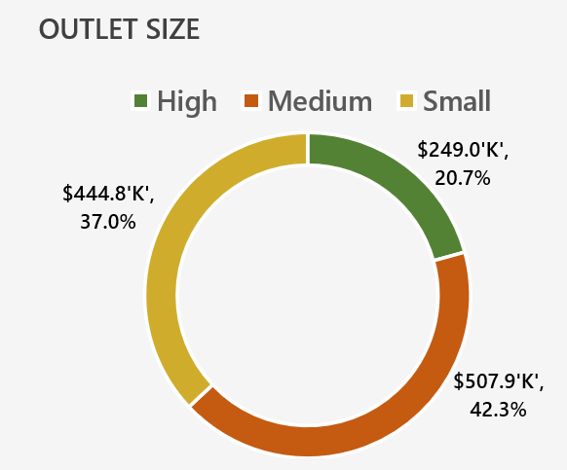
(figure 6: Sales according to fat content performance based on outlet size)

5.4 Category-Level Observations
- High sales categories such as Fruits & Vegetables, Snack Foods, Frozen Foods, Dairy, and Household items significantly influence fat-based sales trends
- Regular fat products dominate impulse-driven categories (Snacks, Frozen Foods)
- Low Fat products perform better in essential and repeat-purchase categories
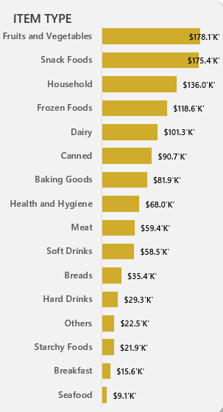
(figure 7: category-wise sale observations)

5.5 Outlet Establishment Trend
- Sales peaked in outlets established around 2018
- Indicates improved outlet planning and maturity contributing to higher revenue.
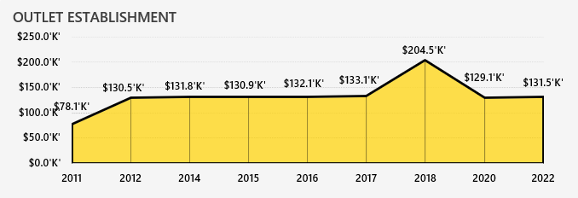
(figure 8: sales by outlet establishment period)

6. Recommendations & Strategic Rationale

Recommendation 1: Optimize Product Mix by Location Tier
Action:
- Increase Low Fat product assortment in Tier 1 locations
- Maintain strong Regular product availability in Tier 2 and Tier 3 outlets
Rationale:
Health-conscious demand is stronger in Tier 1 markets, while value and taste-driven demand dominates other tiers.

Recommendation 2: Focus Medium Outlets for Balanced Assortment
Action:
- Position Medium-sized outlets as core hubs for both Low Fat and Regular products
Rationale:
These outlets generate the highest sales and are best suited for testing new health-focused SKUs without impacting overall revenue.

Recommendation 3: Category-Specific Fat Strategy
Action:
- Promote Low Fat variants in Dairy, Breakfast, and Health-related categories
- Retain Regular variants in Snacks and Frozen Foods
Rationale:
Customer buying behaviour varies by category; aligning fat content with usage intent improves conversion.

Recommendation 4: Targeted Marketing & Labelling
Action:
- Highlight “Low Fat” labelling and health benefits in Tier 1 outlets
- Use price promotions for Regular products in high-volume locations
Rationale:
Improves visibility and aligns marketing with customer motivation (health vs indulgence).

7. Business Impact & Problem Resolution
This analysis directly addresses Blinkit’s original business problem by:
- Clearly quantifying the sales impact of fat percentage
- Identifying where and when Low Fat products perform best
- Providing actionable, location-specific recommendations
Expected Business Benefits:
- Improved inventory efficiency
- Higher category-level sales conversion
- Better alignment of product strategy with customer preferences
- Data-driven decision-making for future assortment planning

8. Conclusion
The dashboard and analysis demonstrate that while Regular fat products remain the dominant revenue contributor, Low Fat products present a strong growth opportunity when strategically placed. By aligning fat-based product strategies with outlet size, location, and category behaviour, Blinkit can maximize sales while meeting evolving customer preferences.
This project showcases how data analytics can transform raw sales data into strategic business insights, enabling Blinkit to make informed, customer-centric decisions.
Dashboard:
(figure 1: Overview of the Dashboard)

